

Development Diary 1

Employability



2nd of October 1, 2020

By

Sean Colbourne

# Employability Skills

We were tasked with creating a trading card game within a time limit of four hours, this meant that we had to create rules, player count, design, mechanics and teamwork strategies.

The way this has helped me with my employability skills is that it has helped me to work under pressure and within a client’s time constraints, it has also enabled me to be able to work as a team remotely as this was done primarily online, we used shared resources via Google Docs, our group then presented our game idea to the peers in the room.

# Transferable Skills

The way the skills can transfer into my professional workflow, is by ensuring that I can follow strict time constraints and maintain professionalism throughout the duration of the task and thereafter, it also shows that I’m able to adapt quickly and have a consistent workflow whilst working in a new group with people who I had yet been acquainted with.

# Reflection

After undertaking this activity, I have learnt that not only is working in a team a key functional skill that is needed throughout a workplace and professional environment, but also being able to think and act quickly when approaching a deadline

# Software

Some of the software that I used to help generate ideas are as follows.

Photoshop – I used this software to create a visual representation of the cards for the game

Docs – this was used to document the design rules and other key factors to making the game fun

Slides – this was used to produce our presentation that we used to show our peers our game idea

By using this software it meant that the team could collaborate and input data directly and made it easier to discuss issues that we may have faced with the task, we also used google teams so that we could communicate our ideas before we started documenting the idea on which we settled.

# Assets

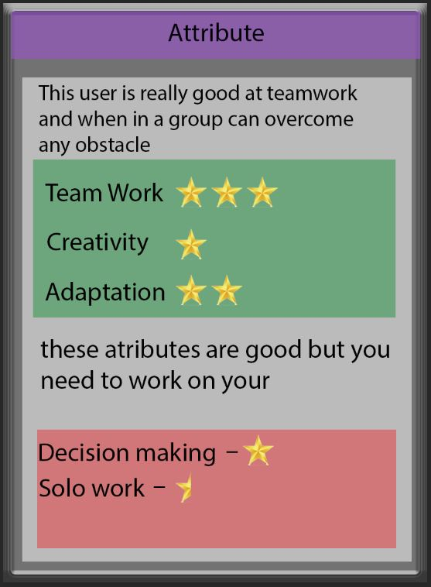

E

D

B

A

Figure.1. Attribute Cards

C

A: This shows you the that this card belongs to the attribute deck

B: This gives players a brief description of the how this card effects the players outcome

C: These stars represent the amount of points you gain via each statistic.

D: This shows that the card has negative effects

E: This shows how many points are negated from your total amount of your overall cards

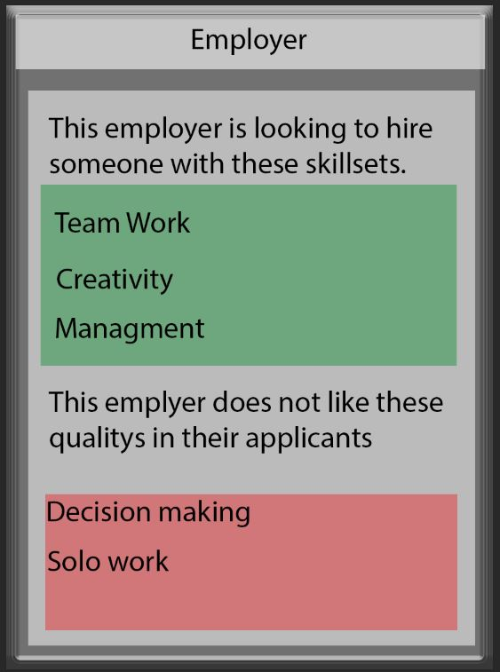

E

D

C

B

A

Figure.2. Employer Cards

A: This shows you the that this card belongs to the employer deck

B: This information tells the players that the employer is looking for specific attributes

C: This information shows what the employer is looking for from the player

D: This shows that the employer does not want these traits

E: The traits are then listed informing the player to avoid these

When creating these cards, we considered people who are colour blind and made the cards accessible to help them read the information easily, we did this by choosing contrasting colours.

By choosing to create the positive effects in a green area and those with negative effects in a red area, we are making it easy to distinguish what stars are to be added and which are to be subtracted. The stars also allow for easy scorekeeping without the need of a high mathematical skill or calculator making it suitable for all ages.